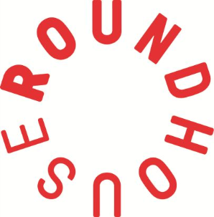
Roundhouse Youth Advisory Board 2018
Application Form

RYAB wants you! If you’ve ever wished you could influence decisions in the Roundhouse, share your opinions about youth related topics or gets experience being a leader – this is your chance.

For more info go to roundhouse.org.uk/ryab2018

Name:
Age:
Which borough do you live in?
Have you been on any Roundhouse projects (which ones)?

Favourite Artist (any art form):
Your email address (so we can contact you):
- Tell us about your interests! We want to hear about your hobbies, classes or activities…

- What do you feel you could bring to RYAB?

- What has been your favourite experience at the Roundhouse?

- What do you want to gain from being a member of RYAB?

- What would you change about the Roundhouse?

- What would you want RYAB to accomplish in the next year?

We’ll contact you by email by the middle of December to let you know if you’ve been shortlisted – make sure to keep checking your emails!
Please send your application to ryab@roundhouse.org.uk or hand in to the studios reception or the Information and Advice Base by Sunday 3 December.

