Roundhouse Access Guide

- Introduction
- Contact Details
- Venue Description
- Bookable Access Facilities
- How to apply
- Travel Guide
7.1 By Tube
7.2 By Overground
7.3 By Bus
7.4 By Coach
7.5 By CarArrival Guide
- Toilets
- Customers with Medical Requirements
- Access to Performance
  - Facilities for Deaf and Hard of Hearing Patrons
  - Facilities for Blind or Vision-Impaired Visitors
  - Venue Accessibility for Wheelchair Users
  - Relaxed Performances at the Roundhouse
- Assistance Dogs
- Strobe Lighting

/////////////////////////////////////////////////

1. Introduction

We’re committed to making all aspects of your visit to the Roundhouse enjoyable, universally welcoming and physically accessible and are proud to have been awarded a Gold Standard Award from Attitude is Everything, recognising our on-going commitment to provide the best possible experience for deaf and disabled visitors

/////////////////////////////

2. Contact Details

To discuss any access-related enquiries, please don’t hesitate to contact us:

access@roundhouse.org.uk

www.roundhouse.org.uk

020 7424 8455 (Roundhouse Dedicated Access Enquiry Number)
0300 6789 222 (Roundhouse Ticket Purchasing)

Roundhouse,
Chalk Farm Road,
London,
NW1 8EH

We will endeavor to respond to your enquiries as soon as possible. Generally speaking, this will be within 24 hours, though postal responses and requests received outside workings hours (weekends and holidays) may take a little longer.

////////////////////////////////////

3. Venue Description

The Roundhouse has step free (lift) access to Accessible Toilets, Bars and Performance Spaces on all levels as well as level access to the Box Office, MADE Bar and Kitchen and Paul Hamlyn Roundhouse Studios on Level 0.

The Main Entrance to the building has level access through power-assisted doors from Chalk Farm Road. The car park offers ramped access to Level 1 (for pre-booked car park users only) via our Stage Door.

Please note that although the Paul Hamlyn Roundhouse Studios are level throughout with a power-assisted internal door, due to the nature of our Grade 2* listed building there are a number of narrow corridors.

For more information on specific facilities, please see the next section.

////////////////////////////////////////////

4. Bookable Access Facilities

We offer complimentary tickets for personal assistants / support workers in order to facilitate your attendance of our venue. As standard, our Wheelchair Positions and other ‘Accessible Seats’ come with one free ticket. Should you require more, please let us know and we will try and accommodate your request. Should you not require a personal assistant or support worker in order to attend then please let us know.

To purchase your ticket(s) and get your complimentary assistant seat(s), call us on 020 7424 8455 or our Ticket Line on 0300 6789 222 or, for wheelchair bookings where one complimentary seat is required, head to our website at www.roundhouse.org.uk. We do not request any evidence for personal assistant ticket bookings.

Although we do not have a viewing platform in the Main Space on level 1 as standard, we have a number of wheelchair positions and ambulant accessible seats on Level 2 when seats are in use. Please note, the availability of seats that have step free access is limited. In standing only shows, wheelchair users are able to gain early access by prior arrangement and we will endeavor to position a number of seats in the space for patrons who might need to make use of them. Please make yourself known to the Duty Manager on arrival to arrange this.

In our Sackler Space, we have a number of wheelchair spaces that are reserved until the performance sells out, at which point they will be put on general sale. For promenade performances, wheelchair users are free to move through the areas and asked to make themselves known to the Duty Manager, prior to doors opening, who will arrange priority entry and be able to advise from where it is best to watch the event.

We have a limited amount of accessible parking on site. Should you wish to request a space, please email us detailing the make, model, colour and registration of the vehicle you will be attending in and we will confirm whether or not we have been able to reserve a space for you. Alternately, give us a call and we will be able to let you know immediately as well as taking the required information.

///////////////////////////////////////////////

5. How to apply to the Roundhouse Access list

We do not operate an access list, but strive to make each performance accessible to all. We have attempted to make the application process for all of our access facilities as smooth as possible. Details of how to apply for each of our various facilities are detailed in the previous section. If any information is missing, you would like clarification or you have any concerns, please don’t hesitate to get in touch via any of the contact methods as detailed in Section 2, ‘Contact Details’. If you would like to request a performance to have an enhanced service please get in touch.

/////////////////////////////////////////////////

6. Travel Guide

There are a number of transport options available for getting to the Roundhouse. Please note it gets very busy in the Camden area and also around Chalk Farm during Roundhouse Events. As well as leaving plenty of time, we recommend that you check the Transport for London Journey planner (https://www.tfl.gov.uk/plan-a-journey/) and Status Updates (http://www.tfl.gov.uk/roads/status/) to check for any disruption to services.

Please note that on occasion we will sell tickets for events that do not take place at the Roundhouse. Always check the event details and your tickets carefully.

6.1 By Tube:

Our closest station is Chalk Farm, located on the Edgeware branch of the Northern Line, at only about 100m away. There’s a sign outside the station pointing you in the right direction! There are a maximum of 22 steps from the platform level to the lift, which will take you up to the ticket hall from where there is level access to the street. Please note that this station tends to be busy for about quarter of an hour after a busy Main Space show finishes. TFL provide extra staff to help manage the crowds and though they encourage people to use the spiral stairs (53 steps), the lift is still in operation.

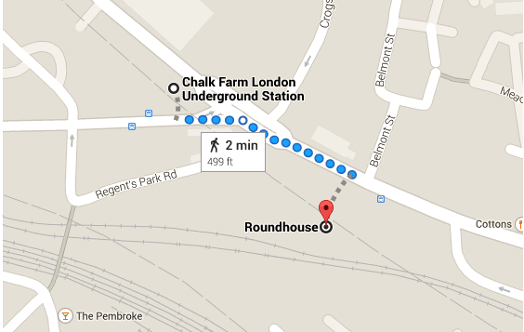

Alternately, Camden Town Station, located on the Northern Line and accessible on either branch, is located about 800m away. Unfortunately there is no step free access from this station.

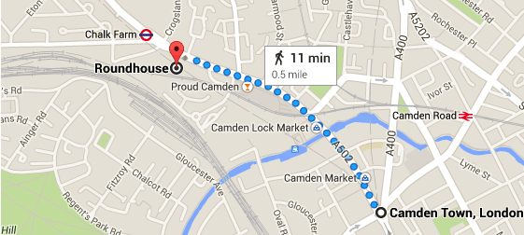

6.2 By Overground:

The closest Overground station is Kentish Town West, on the North London Line (Stratford to Richmond). It is approximately 800m from the Venue. There are 46 steps from the platform to street level.

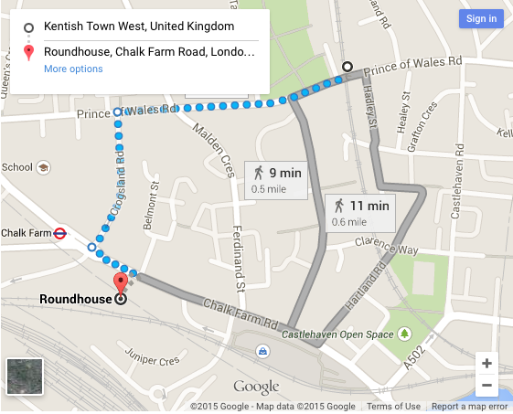

Alternately, for step free access on the Overgound, head to Camden Road. Also situated on the North London Line (Stratford to Richmond), it is located roughly 1200m from the Roundhouse. Lifts operate from the platforms to the street level.

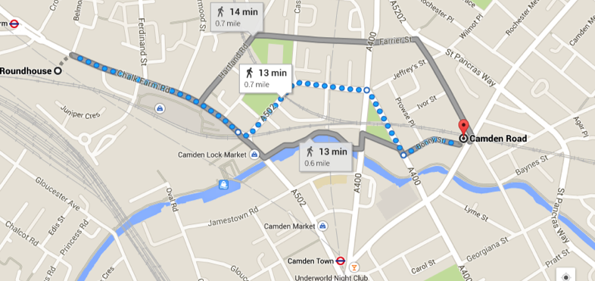

6.3 By Bus:

Many buses run to and from Chalk Farm Road including the 24, 27, 31, 46, 168 and 393.
Buses to and from Camden include 24, 27, 29, 31, 134, 135, 168, 214, 253, 274 and C2.

All TFL bus routes are served by low-floor vehicles, with a dedicated wheelchair space and an access ramp. They can also 'kneel' to reduce the step-up from the pavement.

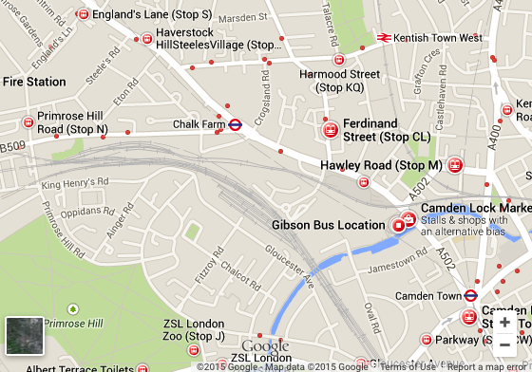

6.4 By Coach:

As we're located on Chalk Farm Road in inner London there are no coach parking facilities nearby.

Vehicles are not permitted to park on the road at the front of the building, however it may be possible to drop off at the front of the building depending on the volume of traffic at the time of your arrival.

If you are arranging for a coach to collect you at the end of the event, please be considerate to our local residents and do not allow the driver to wait on the road with the engine running. Pick-ups should be well organised, quiet and quick so as not to disrupt the local traffic area.

6.5 By Car:

Space is of a premium around the Roundhouse. However, we do have a limited number of parking spaces for Blue Badge holders.

These spaces are allocated on a first come first serve basis, so please get in touch by email to reserve your space or call us on 020 7424 8455.

To make a booking, you will need to provide us with; what show/project you are attending, your Order number, your Customer number, the registration of the vehicle you will be attending in as well as the make and colour and a contact phone number where we can reach you. Parking is generally available from 1 hour before the start of the event.

Taxi drop offs can be made in front of the main entrance to the building from Chalk Farm Road.

///////////////////////////////////////

7. Arrival Guide

Our standard opening hours are:
9:30am-9pm Tuesday to Friday
9:30am-5pm Saturday to Monday

On show nights, we open the Box Office for collections two hours before the advertised door time which can be found by looking on the performance information page or getting in touch with us. If you want to come and collect your tickets early, you can do so during our standard opening hours, unless you have been instructed otherwise from doing so by email

The main entrance to the Roundhouse, as viewed from Chalk Farm Road, looks like this;

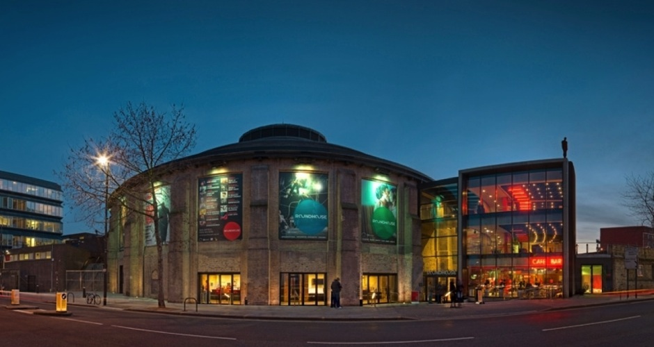

Wheelchair Access

Studios Box Office Main Entrance
There are a few steps leading down to the venue towards the right hand side of this image, by the main doors. For wheelchair access, aim to the left of the Studios entrance where there is a dropped curb, marked ‘Wheelchair Access’ above. From here, you can access the ramp to all other entrances. If you need to collect tickets, enter via the Box Office. If you already have your tickets on you, feel free to use the Main Entrance.

When you arrive, there might be fencing and a queue down the road of people waiting to get in. There will be Security Stewards directing this queue – if you require early access, make yourself known to one of these Stewards who will be able to contact the Box Office Manager, Duty Manager or Assistant Manager on your behalf, who will in turn be able to direct you of the best course of action. Alternately, come straight to the Box Office from where we will also be able to assist.

To pick up your tickets, you will need a form of identification – a payment card will suffice unless the performance information specifically states that you’ll need to produce photographic ID. You will also be asked to verify your post code too. This is to ensure we’re giving the tickets to the right people! You will not be asked for any ‘proof of disability’ to pick up your access tickets though you or others in your party may be asked to provide proof of age to pick up any concessionary rate tickets or if there is an age restriction on the event.

If you have requested any other Access Facilities such as the use of one of our wheelchairs or Hearing Enhancement Systems (Main Space and Sackler Space only), this will be available for collection from Box Office also. There is a dropped counter on both sides of the counter.

Once you’re inside, there will be a number of Security Staff as well as Venue Assistants and Visitor Services Assistants. Should you require any assistance or you have any concerns or questions, please don’t hesitate to ask any of them for assistance.

///////////////////////////////////////

8. Toilets

Accessible toilets are available on all floors and are positioned:
• In the foyers opposite the lift on Levels 0, 1 and 2.
• In the Paul Hamlyn Roundhouse Studios.
• Inside the Main Space on Level 1.

We also have an accessible baby changing facility next to the Studio Theatre on Level 0 and in the Main Space level 1. All fittings comply with Part M of the Building Regulations.

We do not currently offer a Changing Places toilet facility, but are hoping to include this in our next refurbishment.

//////////////////////////////////////

9. Customers with Medical Requirements

We welcome attendees who need to bring medicines, medical equipment, food or drink to manage a medical condition. If you have any concerns about being allowed entry with any items you require, please don’t hesitate to get in touch. For music performances and large scale events, we have trained medics on site and all of our Duty and Management Staff are First Aid trained.

////////////////////////////////////////

10. Access to Performance

10.1 Facilities for Deaf and Hard of Hearing Patrons:

Our box office desk and MADE Bar and Kitchen is equipped with a hearing loop system for those using hearing aids.

The Main Space and the Studio Theatre are equipped with a Sennheiser Hearing Enhancement System. If you would like to make use of this service, please ask at the box office and they will be able to issue you with a compatible headset to enhance the sound or to link to your hearing aid.

Details of captioned or signed performances, will be listed under the dates and times tab on individual production pages. Alternatively, you can search for British Sign Language, Audio Description or Relaxed Performance in our search function on the website. If a performance doesn’t have any dates listed and you would be interested in using this service please get in touch with us via access@roundhouse.org.uk and we may be able to arrange this.

10.2 Facilities for Blind or Vision-Impaired Visitors:

If you have a form of vision impairment, our staff will be happy to assist if you require and our foyer signage is tactile and in braille.

Should you require braille or large print material please let us know in advance by emailing access@roundhouse.org.uk. Or calling us on 0207 424 8455

Assistance animals are welcome in all areas and although we would recommend keeping them with you, if you would like us to look after them whilst you enjoy a performance this can be arranged again by emailing us at access@roundhouse.org.uk. Or calling us on 0207 424 8455

Details of audio-described performances will be listed under the dates and times tab on individual production pages. Alternatively you can search for Audio Description on our website for a list of upcoming events. If a performance doesn’t have any dates listed and you would be interested in using this service please get in touch with us via access@roundhouse.org.uk and we may be able to arrange this. The Roundhouse has a number of staff who are trained Audio Describers.

10.3 Venue Accessibility for Wheelchair Users:

We have lowered counter positions at the Box Office, Cloakroom and Paul Hamlyn Roundhouse Studios reception.

Our Main Space is very flexible meaning that the position of wheelchair spaces changes depending on the demands of the event taking place.

We offer a number of wheelchair spaces within seated areas at performances for when seats are in use. In standing areas for gigs or for all-standing shows there is no raised viewing platform for wheelchair users. For such performances, please make yourself known to our Duty Managers prior to doors opening, who will arrange priority entry and be able to advise where best to watch the event.

In the main space our level 2 wheelchair spaces consist of a seat for a personal assistant and a space for a wheelchair. It is not possible to add in a seat into the wheelchair space so anyone using it will have to be using a wheelchair.

In our Studio Theatre, we have a number of wheelchair spaces that are reserved until the performance sells out, at which point they will be put on general sale. In the Sackler Space it is possible to put a chair back in to the space if you decide you would like to transfer from your wheelchair into a seat, just let the Duty Manager know. For promenade performances, wheelchair users are free to roam standing areas and asked to make themselves known to the Duty Manager, prior to doors opening, who will arrange priority entry and be able to advise where best to watch the event.

Although our bars do not have dropped counters for service to wheelchair users, our bar staff are briefed to come out from the bar to take your order.

There are accessible toilet facilities on all floors.

In addition to our wheelchair spaces, we also have several wheelchairs for those with limited-mobility which can be booked for use during your visit by arrangement with the Box Office.

All wheelchair spaces can be booked in-person, over the phone on 0300 6789 222 or you can contact us online.

10.4 Relaxed Performances at the Roundhouse:

At the Roundhouse we always aim to be welcoming and accessible to all and as part of our commitment, we are able to offer relaxed performances for certain productions.

Relaxed performances are aimed at encouraging and welcoming audiences who could benefit from a more relaxed environment including those with a condition on the autistic spectrum, people with learning difficulties, sensory or communication needs, so they can enjoy and experience live performance.

We aim to create an experience that removes and reduces obstacles to attendance including anxiety and unfamiliarity through creating a supportive and less formal atmosphere.

As part of our commitment we will:

- Maintain the artistic integrity of the show.
- Provide a link to a tour of the building and a visual story so audiences can familiarise themselves with building and space.
• Open the house earlier than usual to allow those audience members the opportunity to arrive early, familiarise and settle in before the performance.
• Allow food and drink in to the space (though strictly no glass in performance spaces).
• Welcome and meet the characters from the production to explain the story and introduce the characters before the performance begins.
• Adjust aspects of the production’s light, sound and participation as required
• Provide a chill-out space if any member of the audience feels they need to leave the performance space.

Relaxed performances will be identified under the dates and times tab on event pages and tickets can be booked online.

With any performance at the Roundhouse please feel free to get in touch with us if you need any information on an event to help you make a decision if it’s going to be right for you.

/////////////////////////////////////////////////

11. Assistance Dogs:

Guide dogs & Assistance dogs are all allowed to enter the building. If you would like your dog to be looked after whilst you are watching an event, this can be pre-arranged by getting in touch in advance. We will arrange for someone to meet you at Box Office, guide you to your seat and stay with your dog throughout the event.

/////////////////////////////////////////////////

12. Strobe Lighting:

Occasionally, performances will use Strobe Lighting. We do our best to dissuade productions from doing so as we appreciate it will prevent some people from attending. We will update the relevant Performance Information page on our website if it is being used. If you have any concerns, please get in touch. Please note, though we will do our best to get back in touch with a solid answer in good time, we may have to chase external promoters to get this answer so it mightn’t be as quick as would be ideal. If strobe lighting is being used as part of a performance that you have purchased tickets to, we will of course offer a refund or exchange.

