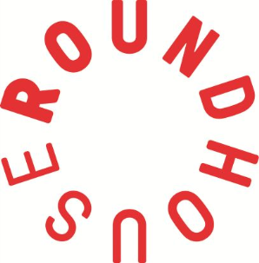
Roundhouse Youth Advisory Board 2019
Application Form (Deadline: 02/12/2018)

RYAB wants you! If you’ve ever wished you could influence decisions in the Roundhouse, share your opinions about youth related topics or gets experience being a leader – this is your chance. For more info go to http://www.roundhouse.org.uk/about-us/whos-who/roundhouse-youth-advisory-board/ OR email ryab@roundhouse.org.uk

Name:
Age:
Which borough do you live in?
Email address (so we can contact you):
Have you been on any Roundhouse projects (which ones)?

- Tell us about your interests! We want to hear about your hobbies, classes or activities…

- What do you feel you could bring to RYAB?

- What do you want to gain from being a member of RYAB?
- What has been your favourite experience at the Roundhouse?

- What would you change about the Roundhouse?

- What would you want to change about your community?

We’ll contact you by email by the middle of December to let you know if you’ve been shortlisted – make sure to keep checking your emails!
Please send your application to ryab@roundhouse.org.uk or hand in to the studios reception or the Information and Advice Base by Sunday 2 December 2018.

