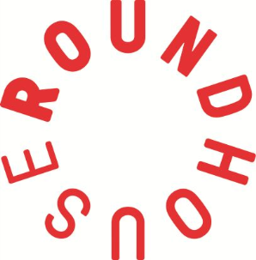
Roundhouse Youth Advisory Board 2021
Application Form (Deadline: 9am Monday 29 March 21)

RYAB wants you! If you’ve ever wished you could influence decisions in the Roundhouse, share your opinions about youth related topics or gets experience being a leader – this is your chance. For more info go to http://www.roundhouse.org.uk/about-us/whos-who/roundhouse-youth-advisory-board/ OR email ryab@roundhouse.org.uk

You can submit your answers to the questions below in the following formats;
- Written – using the application form template
- Video recording of your answers to the questions below
- Voice note of your answers to the question below

Name:
Age:
Which borough do you live in?
Email address (so we can contact you):
Have you been on any Roundhouse projects (which ones)?
- Tell us about your interests! We want to hear about your hobbies, classes or activities…

- What has been your favourite experience at the Roundhouse?

- What would you like to learn / how do you feel that you will benefit from being a member of RYAB?
- What could Roundhouse improve / what changes would you like to see (please provide examples)?

- If you could make a change in the world what would it be?

We’ll contact you by email on Tuesday 30 March to let you know if you’ve been shortlisted – make sure to keep checking your emails!
Please send your application in written form, video or voice note to ryab@roundhouse.org.uk by 9am Monday 29 March 2021.
RYAB meetings take place every first Tuesday of the month, from 6.30pm – 8pm (April 21 to March 2022 initially remotely).

